Group Members:

Muhammad Ahsan Shakeel (24280063)

Saad Muzammil (24280045)

Implementation

Architecture Diagram

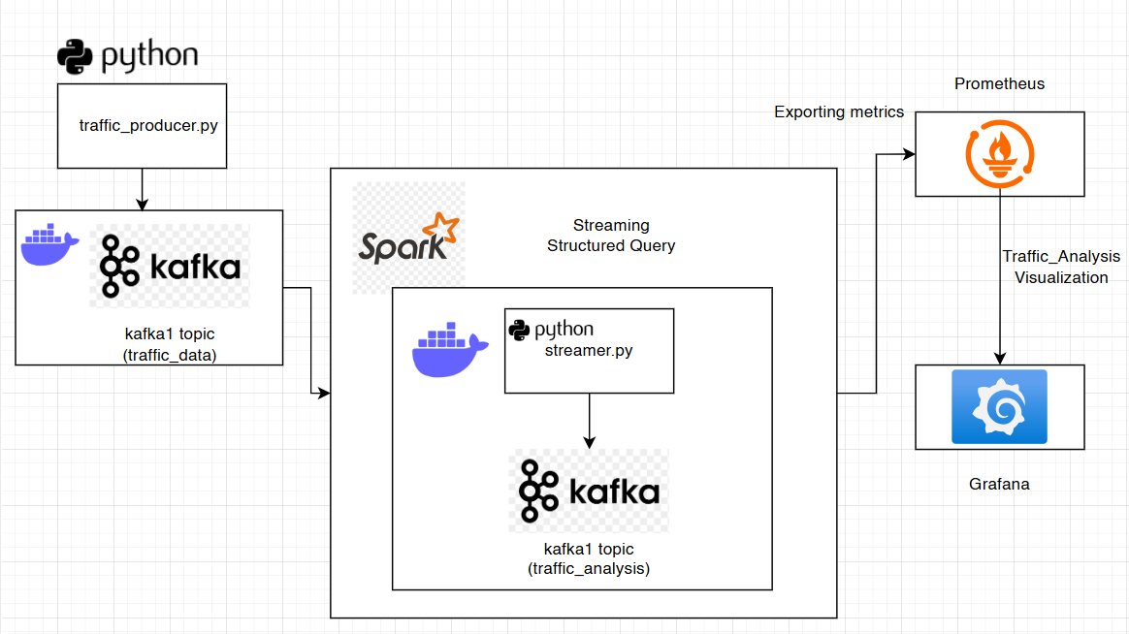

Part 1: Kafka Producer
First all the requirements were fulfilled via docker compose. Zookeeper, Grafana, Prometheus and kafka were installed.
Then a virtual environment was created and following commands were executed:
- python -m venv env (creating virtual environment)
- source env/bin/activate (entering in it)
- docker-compose -f zk-single-kafka.yml up -d (running up all the files i.e kafka etc)
- Then we have to create topics inside kafka container.
- docker exec -it kafka1 /bin/bash (for going in kafka)
- kafka-topics --create --topic traffic_data --bootstrap-server localhost:9092 --partitions 1 --replication-factor 1 (for creating traffic_data)
- kafka-topics --create --topic traffic_analysis --bootstrap-server localhost:9092 --partitions 1 --replication-factor 1 (for creating traffic_analysis)
Then running the producer using python producer.py
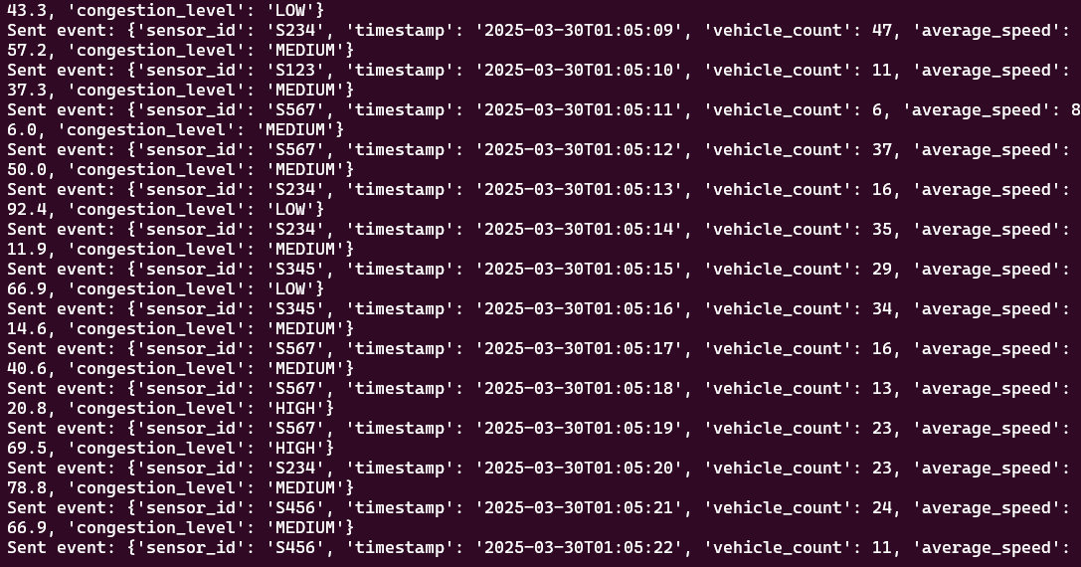
Part 2: PySpark Structured Streaming
For part 2 we created streamer.py and added all the required analysis tasks in it. (please refer to the code file)

Part 3: Data Quality Checks
Implemented all the required data quality checks in streamer.py (please refer to the code file)

Part 4: Output Storage & Visualization
Wrote streaming data to kafka topic “traffic_analysis” created earlier. Configured kafka by exporting its metrics onto Prometheus for visualization on Grafana. Developed 2 dashboards:
- Traffic volume over time (time series)
- Average Speed per Sensor

Traffic Volume over time dashboard:
Implemented Traffic volume over time.
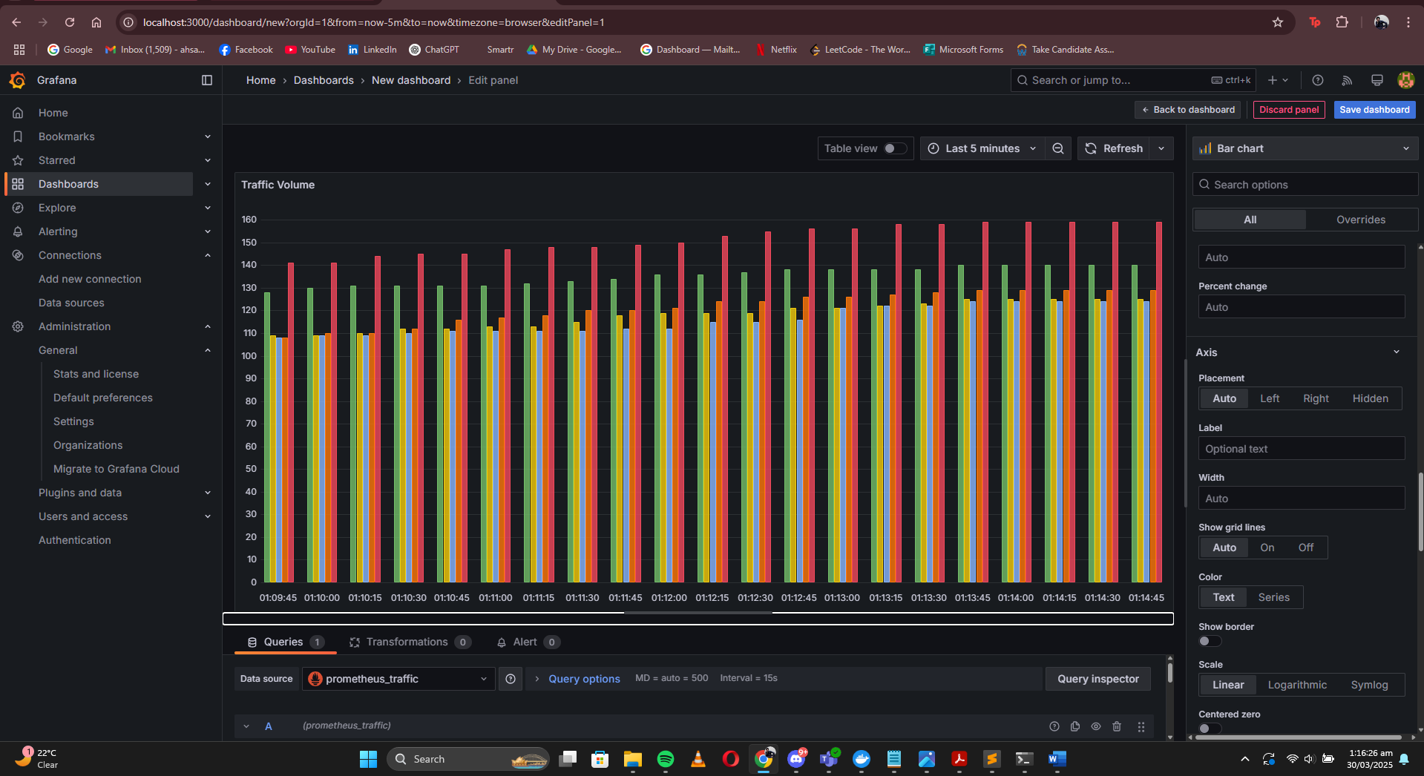

Average Speed per sensor:
Implemented average speed per sensor in km/h over 10 min window :
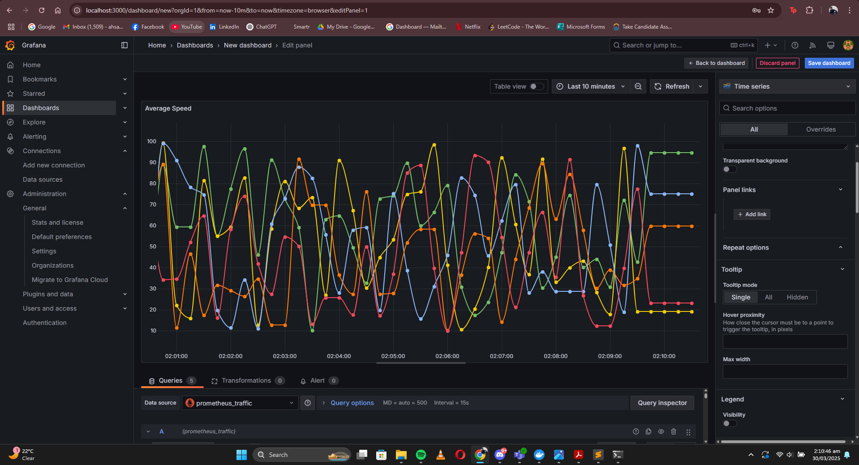
(Verified this by running query on Prometheus as well and matched the output)

